6.69: a) 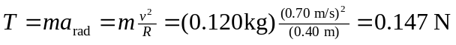, or 0.15 N to two figures. b) At the later radius and speed, the tension is 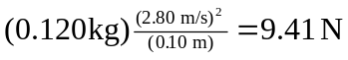, or 9.4 N to two figures. c) The surface is frictionless and horizontal, so the net work is the work done by the cord. For a massless and frictionless cord, this is the same as the work done by the person, and is equal to the change in the block’s kinetic energy, . Note that in this case, the tension cannot be perpendicular to the block’s velocity at all times; the cord is in the radial direction, and for the radius to change, the block must have some non-zero component of velocity in the radial direction.

